1 Purpose: 2
2 Scope: 2
3 Software Architecture 2
3.1 High Level Architecture 3
3.1.1 Instrument Engine (IE) 3
3.1.2 IE Proxy 4
3.1.3 Automation Interface (AI) 4
3.1.4 Front Panel Processes (FP) 4
3.1.5 Analysis and Measurement Layer 4
3.1.6 Services 4
3.1.7 Web Page Processes (WP) 4
3.1.8 Known Concerns 4
3.1.9 Future Advantages 5
3.1.10 Simple example walkthrough 5
3.1.11 Process boundaries/Threads 5
3.1.12 Alternate Architecture Considered 6
3.2 Detail Level Architecture 8
3.2.1 Automation Interface (AI) 8
3.2.2 IE Proxy 8
3.2.3 Services 9
3.2.3.1 Measurement Library (ML) 9
3.2.3.2 File Formatting 9
3.2.3.3 Licensing 9
3.2.4 Front Panel System (FP) 10
3.2.4.1 Main GUI 10
3.2.5 AML Detail 11
3.2.5.1 Signal Flow Framework 16
3.2.5.2 Front panel event flow mechanism 18
3.2.5.3 Channel, Mode and Views 20
3.2.5.4 Flowlayout: Channel:Mode:View Binder 21
3.2.5.5 Data Flow 22
3.2.6 Use Cases to clarify system component interaction. 24
3.2.6.1 Instrument Power Up 24
3.2.6.2 Run with configure dialog box 24
3.2.6.3 Stopped with configure dialog box 25
3.2.6.4 Remote SCPI command received and tracked on front panel GUI of instrument: 25
3.2.6.5 Changing parameter using accelerator key: 25
3.2.6.6 Simple Free Run Measurement with averaging: 25
3.2.6.7 Save Configuration: 26
3.2.6.8 Recall Configuration: 26
3.2.6.9 Changing Modes: 26
3.2.7 Web Page Processes 27
3.2.8 Boot Up Sequence 27
4 Design 27

Purpose:
The purpose of this document is to describe the Mirage Software Architecture and Design.

Scope:
The scope of this document is describing the Mirage Software Architecture for the Mirage instrument. This does not include the firmware level architecture contained in the Instrument Engine. See TBD for a description of this architecture.

Software Architecture
This section describes the software architecture.

High Level Architecture
This section describes the high level software architecture and the associated responsibility of the blocks. The figure above shows the major parts of the Mirage Software architecture. The Mirage software will use the Common Development Framework (CDF) provided by TCA wherever possible.

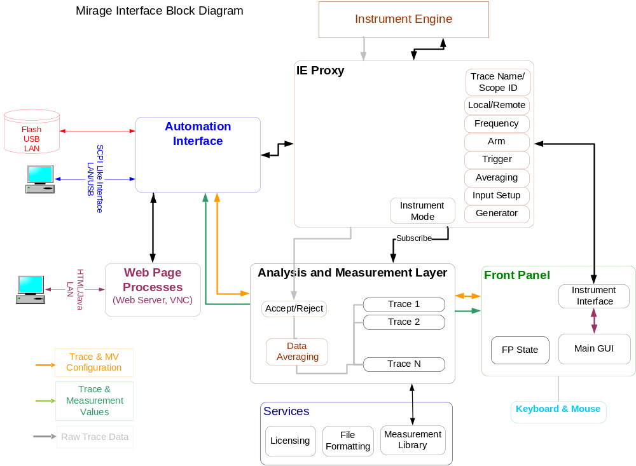

Figure 3.1-1

Instrument Engine (IE)
This block contains the firmware level of the Instrument Engine and is not covered in the scope of this document. The IE will be implemented in unmanaged (aka native) code.

Roles and Responsibilities
- Control the instrument hardware.
- Maintain instrument hardware state.
- Collect measurement data (Time Domain, FFT, and Octave Data)

There are many more responsibilities for this block. See TBD for a more detailed description of the IE architecture.

IE Proxy
The IE (instrument engine) Proxy is central to the software architecture. It provides the connection between the IE and the rest of the software. The IE Proxy communicates with the IE through the Instrument Engine Interface.

Automation Interface (AI)
The automation interface provides the connection between the remote user and the rest of the software. The AI communicates with the IE through the Instrument Engine Interface.

Front Panel Processes (FP)
The Front Panel provides the interface from the instrument to the human using the instrument. The design of chart control in FP is documented at Mirage Chart Emgbest.Mirage\Documents\Designs\Control Design.doc

Analysis and Measurement Layer
The Analysis and Measurement Layer is the calculation center of the software. It exists to build up the measurements and take the raw data from the IE Proxy and transform it into trace and measurement data to be displayed in the GUI or sent back to the user over the remote interface.

Services
The Services Block contains the components that are used by multiple other components in the system. The major services identified so far are:
- File Services
- Measurement Library
- Licensing
The roles and responsibilities of these components will be covered below.

Web Page Processes (WP)
The web page process will contain a VNC server that will server up the trace portion of the front panel display to the web UI running on the remote machine.

Roles and Responsibilities
- Generate and control the GUI.
- Translate Web UI signals into keystroke signals for the front panel? (Should the drawing show connection to front panel instead of AI?)

Known Concerns
The following list expresses the concerns with the architecture that need to be addressed through prototypes or experiments:
- Performance of passing data from the IE (unmanaged code) to the IE Proxy (managed code).
- Performance of the system when passing data across process (task) boundaries.
- Performance of the “Spiderman” SCPI parser in the CDF.

Future Advantages
Having one point of communication to the IE will hopefully help us when it comes time to port the software out of the box onto a PC. The IE Proxy can be re-written for application on the PC to send commands down the LAN instead of directly to the IE.

Simple example walkthrough
This section will walk through the high level architecture by processing a simple command both from the front panel and through the remote LAN interface. For this discussion assume we wish to PRESET the instrument.

Remote Interface Example
- User sends a command like :SYSTEM:PRESET to the instrument via LAN or USB.
- AI receives the command and parses it.
- AI updates status subsystem if errors encountered.
- AI translates parsed command into a call or calls into the IE Proxy and AML.
- IE Proxy sends commands to the IE.
- IE process the calls and notifies IE Proxy when the calls are complete.
- IE Proxy notifies AI status subsystem if errors encountered.
- IE Proxy notifies all subscribers of IE state changes.
- AML notifies all subscribers of AML configuration changes.
- IE Proxy provides data to AML.
- AML transforms data and calculates any configured measurements
- FP pulls data from AML and updates display.

Front Panel Interface Example
- User pushes preset button on the front panel.
- FP gets a character like CTRL P from the hardware.
- FP updates the IE Proxy and its own state.
- IE Proxy sends commands to the IE.
- IE process the calls and notifies IE Proxy when the calls are complete.
- IE Proxy notifies AI status subsystem if errors encountered.
- IE Proxy notifies all subscribers of IE state changes.
- FP updates AML Configuration.
- AML notifies all subscribers of AML configuration changes.
- IE Proxy provides data to AML.
- AML transforms data and calculates any configured measurements
- FP pulls data from AML and updates display.

Process boundaries/Threads
The drawing below shows the process boundaries each of the blocks will be running in.
TBD

Alternate Architecture Considered
Various other architectures were considered for Mirage also. The figures below show a general representation of other architectures considered.

Figure 3.1-2

The major difference between the Alternate Mirage Interface Block Diagram in Figure 3.1-2 and the Mirage Interface Block Diagram in Figure 3.1-1 is how the FP and AI interface to the instrument engine and where the “business logic” for the measurement is implemented.

In both architectures the AI interfaces with the Web Page Process and remote users. However, in the alternate approach, Figure 3.1-2, the FP and AI communicate directly with the Instrument Engine and each implements its own measurement logic using the measurement library. In the approach chosen, Figure 3.1-1, only the IE Proxy communicates with the Instrument Engine and the FP, AI, and AML communicate with this one entity. Also the AML contains the measurement logic for the entire system.

The chosen architecture offers the following advantages:
- IE state changes are contained in one location.
- IE Proxy provides a notification mechanism to all subscribed components.
- One point of communication with the IE will allow the software to be moved to an external platform with fewer code changes.
- Measurement logic implemented in one place allows for synchronization between the remote interface and the FP. Also prevents different logic existing in different places.

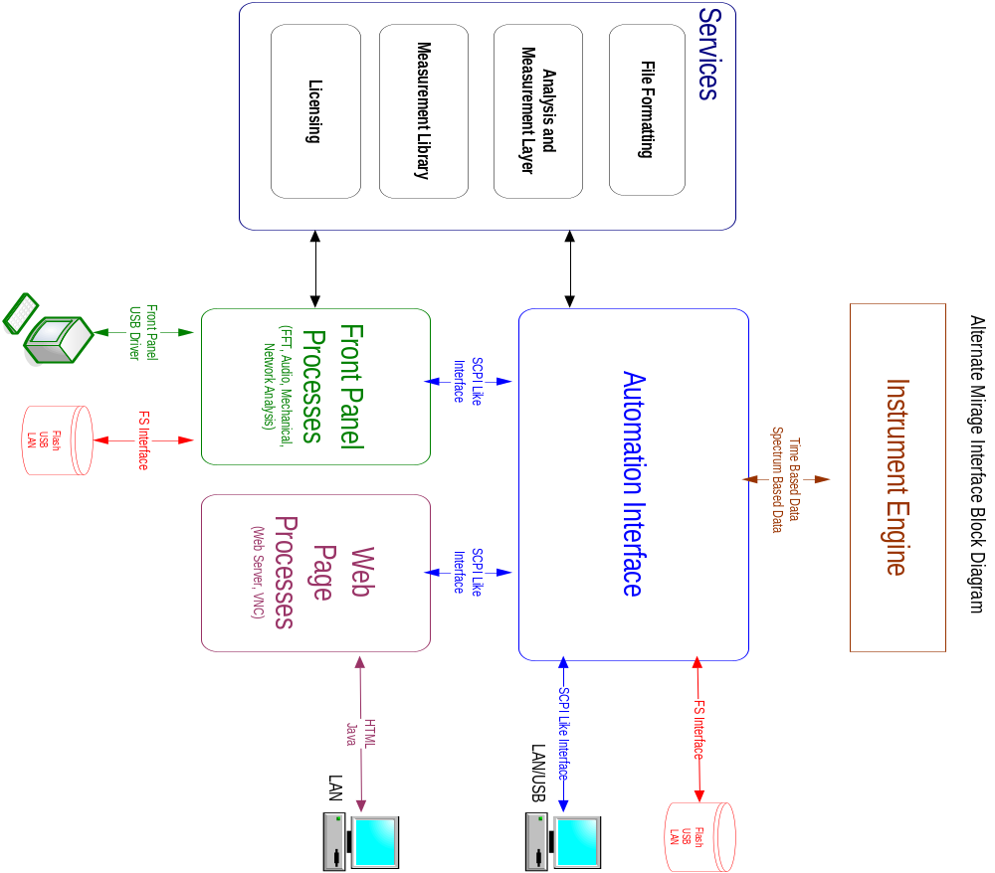

Figure 3.1-3

The major difference between the Alternate Mirage Interface Block Diagram in Figure 3.1-3 and the Mirage Interface Block Diagram in Figure 3.1-1 is how the FP communicates to the IE (indirectly), how the AI communicates to the IE, and where the “business logic” for the measurement is implemented.

In both architectures AI interfaces with the Web Page Process and remote users. However, in the alternate approach, Figure 3.1-3, the AI communicates directly with the Instrument Engine, the FP and AI each implement its own measurement logic using the measurement library, and the FP communicates to the AI using SCPI. In the approach chosen, Figure 3.1-1, only the IE Proxy communicates with the Instrument Engine (similar to the AI in the other approach) and the FP, AI, and AML communicate with this one entity. The AML contains the measurement logic for the entire system. Also, the FP no longer communicates using SCPI.

The chose architecture offers the following advantages:
- IE state changes are contained in one location.
- Removing AI SCPI communication allows the IE Proxy to provide a notification mechanism to all subscribed components.
- One point of communication with the IE will allow the software to be moved to an external platform with fewer code changes.
- Measurement logic implemented in one place allows for synchronization between the remote interface and the FP. Also prevents different logic existing in different places.

Detail Level Architecture

Automation Interface (AI)
Roles and Responsibilities
- Accept and parse remote user requests (SCPI-Like) via LAN or USB
- Convert remote user requests (SCPI-Like) to IE Proxy calls, AML calls, or file system commands.
- Accept commands from the web page.
- Contain status subsystem (for error reporting).
- Handles unique trace names over the AI.

Interfaces
- All of these interfaces are defined in the SCPI syntax document.

IE Proxy
Roles and Responsibilities
- Read and maintain hardware state variables from the IE.
- Notify the rest of the software when a hardware state variable has changed.
- Pass control signals from the rest of the software to the IE.
- Read data from the IE and route to the rest of the software.
- Provide Instrument Engine Simulation to allow development without hardware.
- Contains the local/remote state.

Interfaces
The following file contains the first pass interface definition in code.

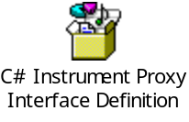

Services

Measurement Library (ML)
The Measurement Library contains the code to provide all data transformations in the system. The role of the ML is for data transformation only. It will not be aware of any instrument states or measurement steps. All information the ML needs to correctly perform will be passed as parameters. This would include any needed instrument state information.

Roles and Responsibilities
- Provide algorithms to transform input data into desired results.
- Handle transformations to both the FP and AI.

The design of ML used in FP by AML is documented at Emgbest.Mirage\Documents\Designs\MeasLib.doc

File Formatting
Roles and Responsibilities
- Provide the data format translation (to UFF, HDF5, CSV).

Interfaces
- TBD

Licensing
Roles and Responsibilities
- Provide licensing mechanism for measurements or modes of operation
- Provide ability to install or remove license
- Provide ability to query for installed license

Interfaces
- Interfaces to licensing will not be available until the development work is done in TSO.

Front Panel System (FP)
The front panel layer is responsible for providing graphical user interface to user. This layer will interact with instrument (HW) through the IE Proxy. These are the main design objectives for Front panel layer.
- Generic
- Extendible
It seems that most of the requirement changes are mostly related to user graphical interface. The FP layer should be generic & extendible enough to handle/absorb future requirements.
The main responsibility of FP layer is to display transformed measured raw data, as per chosen mode with the help of AML and display it on graphical interface.

Roles and Responsibilities
- Generate and control the GUI.
- Generate menu structure.
- Display valid menu choices to user via front panel soft keys.
- Display current location in menu structure.
- Convert interactive user requests (button presses) to IE Proxy Calls, Analysis and Measurement Layer (AML) calls, or file system commands.
- Display trace data and measurements returned from the AML.

Design for FP layer is categorized into different sections, detail designs of these sections are given below.

Main GUI
Roles and Responsibilities
- Accept and interpret key presses
- Generate and control the GUI.
- Generate menu structure.
- Display valid menu choices to user via front panel soft keys.
- Display current location in menu structure.
- Display measured data.
- Configure and control the display.
- Convert interactive user requests (button presses) to IE Proxy, AML, or file system commands.
- Provide infrastructure to enforce implementation of the design patterns. This should be as easy as possible for developers to implement.

Interfaces
The IKeyDesignPattern interface is the interface that will be used to implement the softkey menu pattern when a hard key is pressed. This will also be able to implement lower level menus in the softkey menu tree.

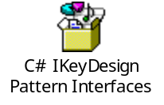

AML Detail
Roles and Responsibilities
- Provide the “business logic” i.e. measurement logic for interactive measurement requests from the FP or the AI.
- Transform raw data into traces or measurement values requested by the FP or AI.
- Synchronize the measurement displayed on the FP with those received from the remote bus.
- Provide Averaging capability for instrument.
- Provide Accept/Reject decision point for preview of trace data.
- Enable/Disable/License measurements based on options and context sensitivity.
- Track the state of the configured AML measurement parameters
- Provide intermediate results (i.e. averaging, curve fitting etc) to the FP.
- Provide final results to FP and AI
- Manage acceptance of data from the IE Proxy.
- Provide status of current configuration and other.
- Notify subscribers of configuration change.
- Add and remove traces.

Figure 3.2-4 and Figure 3.2-5 show local and remote configurations of the AML respectively and illustrate some of the following major concepts in the AML:
- All traces in a single display must have the same measurement data (i.e. linear spectrum, auto power spectrum etc) and trace coordinates (i.e. Log Mag, Phase. Nyquist etc.). These are identified and grouped using a scope ID.
- Each display will be able to display only one scope ID at a time.
- Each trace can have its own unique measurements.
- In local mode the trace names need to be unique for each scope ID, but can be the same in different scope ID’s.
- In remote mode the user will only see the trace name, thus the AI will need to assure unique trace names are generated. We still need to decide if duplicate trace names generate an error or re-configure.
- Remote mode configurations will always be sent only to display 0.

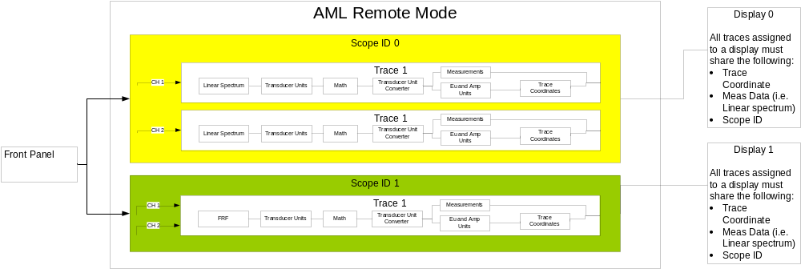
Figure 3.2-4

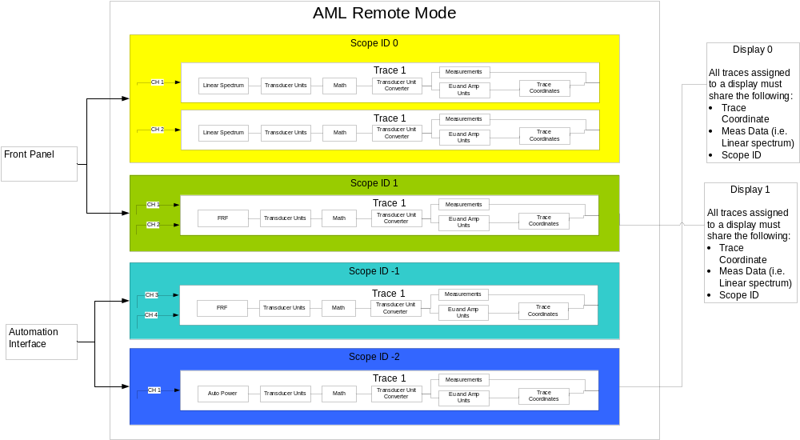
Figure 3.2-5

Figure 3.2-6 illustrates some of the following detail concepts in the AML:
- The AML will contain the current state of the mode, trace coordinate, and measurement values and will communicate changes to those values with events.
- All possible measurement values for a particular mode will be built, but only those valid for the current mode, meas data, and trace coordinate will be enabled.
- Data provided by the instrument engine will be provided to the AML. The AML needs to be assured that this data does not change while it is using it. This will be accomplished either by copying the data, providing a rotating buffer scheme, or IE will allocate new memory and hand it to the AML.
- State information will move through the AML along with the data.
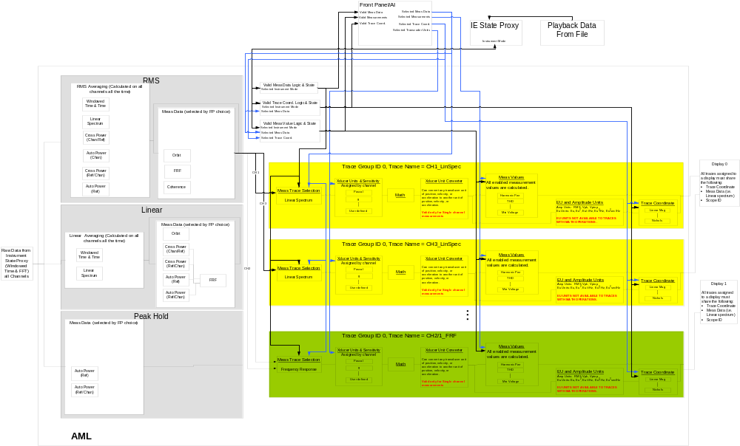
Figure 3.2-6
Side Effects
- When going into remote mode all traces that were routed to display 0 will be disconnected and will not be able to be re-connected. This could result in traces living in memory that are not used. The worst case of this will be 8 channels, 7 meas data types but each scope ID must have only one data type so the largest number of traces that can hang around is 8.
- As each remote trace is configured or fetched, display 0 will update to show that trace. So, if you get a sequence like CONF A, CONF B, FETCH A, FETCH B display 0 will change 4 times.

Questions
- We need to decide if analysis is going to come in after meas data and add the interface to the code. We probably need to add a CreateAnalysis, GetAnalysisNames, DeleteAnalysis.
- Editor for creating Analysis will be outside the AML.
- Need to finalize decision on how to handle errors (exceptions vs. error codes)
- May need to create a call to link makers across scope ID’s
- Should we map the SCPI CONF and FETCH to the active display instead of just display 0.

Interfaces
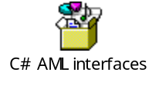

Signal Flow Framework
Signal flow framework is the customized version of golden data path framework which is using C++ as a development language. Signal Flow framework provides the same concept for C# language. This is the basic concept of signal flow framework.
- Different processing blocks connected in a preconfigured ways.
- A chunk of data flows from blocks to blocks (Signal)
- Action block do processing on signal and transform it into more meaningful form
- Blocks may have state, or may act as stateless blocks.
- Blocks may take action synchronously/Asynchronously

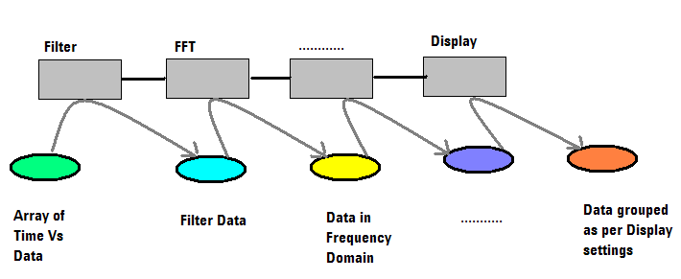

Figure show a basic sequence of block required to display a FFT on a graphic view. A chunk of data start flowing through these blocks and each block has some assigned action/responsibility. That action can be data transformation like FFT or it can be a filter to filter out a specific band of data.
Finally the chunk will reach a Graphic view block, which knew how to display this information to user in meaningful ways. 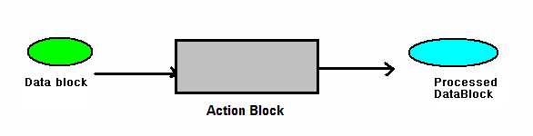

This is the interface protocol for IActionBlock objects. Here Connect/Disconnect will be used to make a sequence of action blocks. Propogate() will flow the DataBlock within this sequence. Interrupt will be used to pass on control events in the flow sequence.
These are the type of control signals
- RESET
- INIT
- START OF DATA
- END OF DATA
- TRIGGER

public interface IActionBlock
{
Connect(IActionBlock);
Disconnect(IActionBlock)
Propogate(DataBlock)
Interrupt(ControlSignal)
}

Below given digram shows the herarchial association of different action blocks. An action block can be a synchronous or asynchronous in nature.
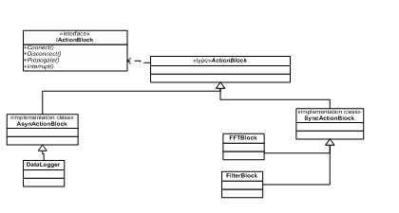

Front panel event flow mechanism
The main responsibility of the front panel event flow mechanism is to interpret, flow, and take action on the different events (user activity) appropriately. The following diagram illustrates the event flow mechanism.

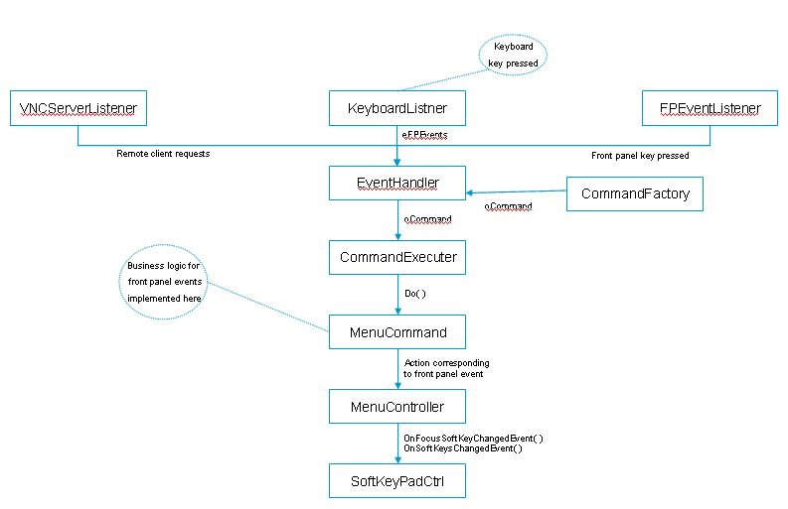

The user can interact with FP layer through the following:
- VNC client ( Remote desktop)
- Front Panel hard/soft keys
- Keyboard ( For prototyping only)

Here listeners (VNCServerListener, KeyboardListener, and FPEventListener) will listen to user interaction from the sources listed above. Each user activity will be interpreted and converted into front panel common events type (eFPEvents).

All the eFPEvents will be directed to EventHandler. EventHandler will create a respective command object using CommandFactory. In Front panel layer every interaction will finally take a form of command, which will be smart enough to take action appropriately. CommandFactory will create these commands object and set the initial required state.

All the commands will route through a common execution channel (CommandExecuter). CommandExecuter will keep a history of executed commands.

Each command object has the extra responsibility of preserving the current state, to allow the implementation of UNDO functionality. This is the functionality prototype of ICommand interface.
public interface ICommand
{
int Do();
int Undo();
}
This is the detail description of individual objects roles and responsibility.
- VNCServerListener, KeyboardListener and FPEventListener
These objects will delicately listen /observe the user activity and transform them to common front panel events (eFPEvent).
- Eventhandler: Eventhandler will responsible for creating a command object as per the front panel event type. It will also responsible for initializing the initial state of this command object. After creating this object, it will route this through CommandExecuter.
- CommandExecuter: This will execute the command and also keep a history of recently executed command. Number of command in history will be configurable. This history will be used to implement the UNDO functionality.
- Command: Command object is a representation of self contained user activity. These objects are responsible for transforming the user interaction into an action. If the action is going to change the state of any other sub-system, functional entity, then this object has extra responsibility of preserving the required information, required to rollback the performed action. CommandExecuter will use this preserved information to implement UNDO functionality.

Channel, Mode and Views
Channel, Mode & views form the three basic elements of Front panel layer.
Channels will act as a source of raw data, a channel can be a physical channel at instrument front panel, or it can be an internal source, it can be a mathematical channel. Each channel has some configurable properties, and it is responsible to flow the raw (Time) data through out the system.
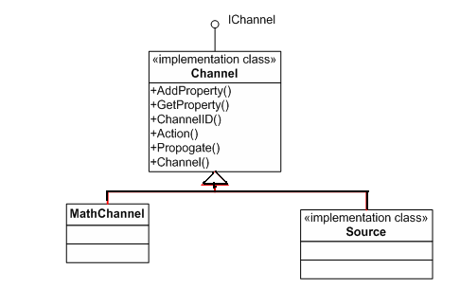

On the other hand mode will act as the measurements need to be applied on the time (raw) data. More specific, Mode is a set of measurements, which transform the raw data as per the chosen measurement domain. Each mode has its own configurable settings, which is stored in the properties containers.
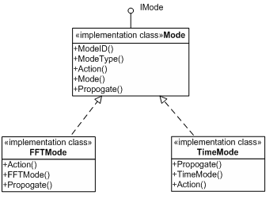

View will act as a graphical interface for the transformed data. View will be specific to the Measurement mode and it also provides the intermediate results.
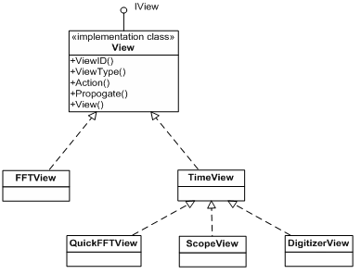

Flowlayout: Channel:Mode:View Binder
Channel, Mode & View all need to be interconnected with each other to make a measurement and displayed the final results to end user. In this interaction mode plays a central role. In this relationship, mode can be connected with multiple views e.g Trace and Data displayed in grid format. A Mode can have multiple sources (channels) of data. Here the compatibility of Views and channels with mode need to maintained. This requirement of holding these three entities together and making the required flow, and validating the compatibility factor of threes items with each other originate a concept of another logical entity termed as FlowLayout.

FlowLayout: Logical entity, which will hold channels, mode view together and connect them as per the requirement of measurement, validate the compatibility of View, channels with Mode. DSA (singleton class, representing DSA as a whole instrument) have the collection of Flowlayout object. Whenever a user chooses any domain/Mode, a layout object will be created with the specific Mode. After that users will select/assign views and channels to that mode. Flowlayout will use signal flow mechanism to connect these three objects together.
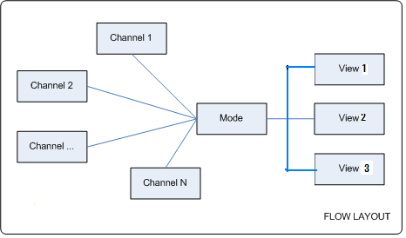
This is the interface for IFlowlayout.

public interface IFlowLayout
{
void AttachChannel(IChannel oChannel);
void AttachChannel(IChannel[] oChannel);
void DetachChannel(IChannel oChannel);
void DetachChannel(IChannel[] oChannel);
ArrayList GetChannels
{
get;
set;
}

void AttachMode(IMode oMode);
IMode GetMode
{
get;
set;
}

void AttachView(IView [] oView);
IView GetView
{
get;
set;
}
}

Data Flow
This section cover’s the trace data flow between AI and Front panel layer. How it gets transformed and flows between few major blocks in FP layer itself. It assumes that raw trace data will be encapsulated in the form data block. Data block will act as a repository of all the raw, transformed data. All the intermediate results and measurement function call cashes will be stored in data block itself.
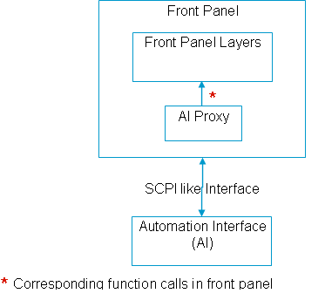
All the calls from FP to AI will route through AIProxy object. AIProxy will expose functionality required to start/pause/continue scanning or upload/download DSA state
etc. AIProxy acts as a communication protocol between FP and AI layer. Mirage can have two different type of AIProxy implementation
- Real Proxy
- Simulated Proxy
Real proxy will convert the function calls into suitable SCPI sequence and execute them. This will interact with AI layer using SCPI language through LAN, inter-process driver. The query result will be wrapped and return back to calling objects in FP layer.

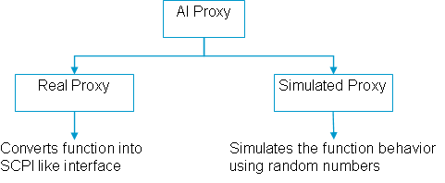
Simulated Proxy will simulate the function call response using measurement libraries and random data generator.

This is the interface for AIProxym, at this moment it has only RunContinous/RunOnce functions. This interface tends to change frequently as we get more clarity about the type of interaction between FP and AI layer. But AIProxy will be the centralized contact point.
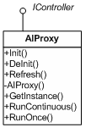
AIProxy will wrap the trace data into Data block and flow it in a predefined sequence of channel → Mode → View objects. Modes will again a sequence of multiple measurements objects connected in a sequence. Each of these transforming objects either transforms the raw time data into another form or does some measurement analysis on the data block. All the transformed data, intermediate results will be pushed back to Data block data attributes dictionary.

Below given picture show the changes in data block while calculating THD. Here the mode object represents a THD measurement sequence. Channel will act as a source of raw time data and get transformed and analyzed through multiple measurement object connected in Mode wrapper. Finally the view/display object will take the responsibility to display it in a useful way.

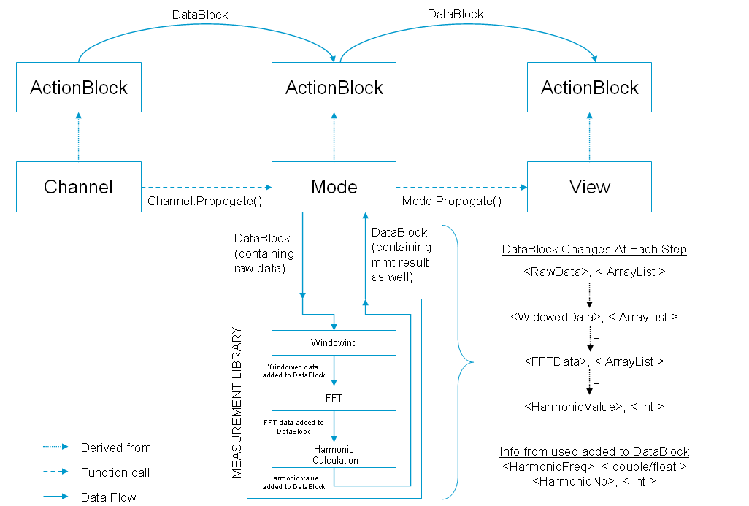

This is the pseudo code for connecting various transforming objects in a sequence.
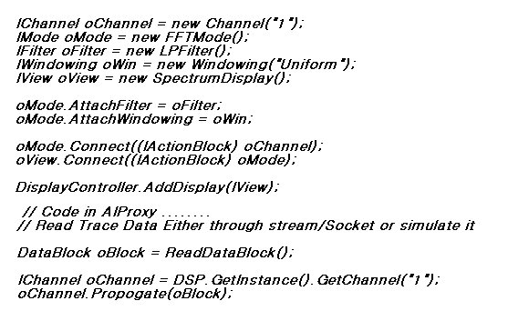

Use Cases to clarify system component interaction.

Instrument Power Up
- User turns on power.
- Agilent Splash screen appears
- Initializes Instrument Engine
- Number of DAQ Channels determined.
- Number of Source Channels
- Licenses are determined.
- Initializes IE Proxy with Channels and source Channels
- Initializes AML with Channels and source Channels
- Kicks off AI with # Channels and source Channels, actually creates 4 AI’s
- Kicks off Main GUI with number of Channels and source channels
- Kicks off the Web Server.
- Startup exits if all is well.

Run with configure dialog box
- User presses configure frequency key.
- AML running needs to stop accepting data (so we do not corrupt data)
- Do we build an AML for each dialog now?
- Current data from IE displayed in this new AML
- Configure frequency dialog box comes up and displays a trace. The data in this dialog box is the data from the IE.
- As the parameters are adjusted, they are validated against II, IE is updated, new data gathered and displayed in the dialog.
- If OK is pressed, dialog AML is disposed of and new parameters are applied to the “main” AML.
- If CANCEL is pressed, dialog AML is disposed of and parameters thrown away or restored.
- Start main AML gathering data again.

Stopped with configure dialog box
- If stopped data from main AML is displayed in the dialog box. If stopped with no data on the screen the dialog box will also not have any data displayed.
- Otherwise the same as Run.
- Use can push ‘RUN” and “Stop” keys while dialog is up and see updates.

Remote SCPI command received and tracked on front panel GUI of instrument:
- User sends SCPI command over LAN/USB.
- AI recognizes remote access and sends command to IE Proxy, which in turn notifies II to lock out the front panel.
- AI takes over control of the Data Pacer sending data to AML.
- At this point the display would remain the same and data flowing from data pacer to AML would be controlled by AI.
- AI accesses IE Proxy to check the validity of new parameter value.
- New settings passed to IE and hardware updated
- IE Proxy notifies subscribers of state change
- AI configures AML.
- AML notifies subscribers of configuration change.
- New data gathered from IE and passed to AML
- AML access new raw data and calculates new trace or measured value
- New trace or measured value passed back to AI.
- New trace or measured value passed to GUI for display.

Changing parameter using accelerator key:
- User presses frequency key.
- User presses the span accelerator soft key.
- Enters new span value by keypad or turning knob.
- II validates new parameter value with IE Proxy.
- IE Proxy sends new state on to IE.
- IE Proxy notifies subscribers of state change
- GUI configures the AML with new parameter.
- GUI triggers new data from Data Pacer to the AML
- AML calculates new trace or measurement value.
- GUI gets new data from AML and displays it.

Simple Free Run Measurement with averaging:
- User presses the averaging key and enters the number of averages.
- II validates command with IE Proxy
- GUI configures AML for averaging, specifically around immediate results.
- GUI triggers each record of data from Data Pacer to AML (in free run mode this data is not buffered in the IE)
- Data sent to AML and the averaging takes place.
- GUI would read back intermediate results and display at this point if appropriate.
- Process continues until the desired number of averages is complete.
- Completed measurement or trace displayed on the screen.
- When total number of averages is collected screen may or may not be continually updated depending on the type of averaging selected.
- NOTE: in free run mode the averages are not guaranteed to be consecutive time records.

Save Configuration:
- User presses system hard key.
- User presses File->Save Configuration soft key.
- GUI displays the Save configuration dialog box.
- User selects the desired directory for saving the configuration.
- User selects the items in the configuration they want to save.
- GUI calls to each of the applicable components (AML, II, AI etc) to serialize their state.
- GUI collects these serialized objects and passes them to the File Formatting along with save destination for saving.
- GUI gives feedback to the user that save was complete

Recall Configuration:
- User presses system hard key.
- User presses File->Load Configuration soft key.
- GUI displays the Load configuration dialog box.
- User selects the desired directory for loading the configuration.
- GUI displays list of configuration files in the selected directory.
- User selects the desired configuration file from a list.
- User selects the items in the configuration they want to save.
- GUI validates new states with II via the IE Proxy.
- IE Proxy updates the hardware state and notifies subscribers of change.
- GUI creates new AML from recalled configuration data.
- GUI triggers new data from data pacer sent it to AML.
- AML calculates new values and sends back to the GUI for display.

Changing Modes:
- User presses the Analyzer Type hard key.
- User presses the Select Analyzer softkey and selects new mode type from list.
- GUI will validate all the current parameter settings for the new mode selected. The hardware settings will more than likely not change. Other settings like averaging, windowing, measurement graph, trace coordinates, triggering … will need to be checked to assure they are still valid for the new mode. If the any of the parameters are not valid for the new mode, the default values will be used.
- GUI will create new AML.
- GUI triggers new data from data pacer sent it to AML.
- AML will calculate new trace or measurement values and pass the results back to GUI for display.

Web Page Processes

Boot Up Sequence
The boot up process will control the sequence in which the various software components in the system are created. The suggested interface looks like:

public interface Startup
{
//PreBoot gets a componet to a state where it
//is ready to communicate with other components
bool PreBoot();

//Boot is where components would begin communication
//with each other.
bool Boot();

//PostBoot would be where components did any final cleanup
//before being fully ready for operation.
bool PostBoot();
}

public interface Shutdown
{
//PreShutdown gets a componet to a state where it
//is ready to end communication with other components
bool PreShutdown();

//Shutdown is where components would stop communication
//with each other.
bool Shutdown();

//PostShutdown would be where components did any final cleanup
//before being fully ready for disposal.
bool PostShutdown();
}

The initial guess at the sequence for booting the components is:
- IE Proxy
- Services
- AML
- Front Panel
- Automation Interface

The initial guess for the shutdown sequence would be the reverse of the boot up sequence. These will change software components are actually written and built.

Design
TBD

